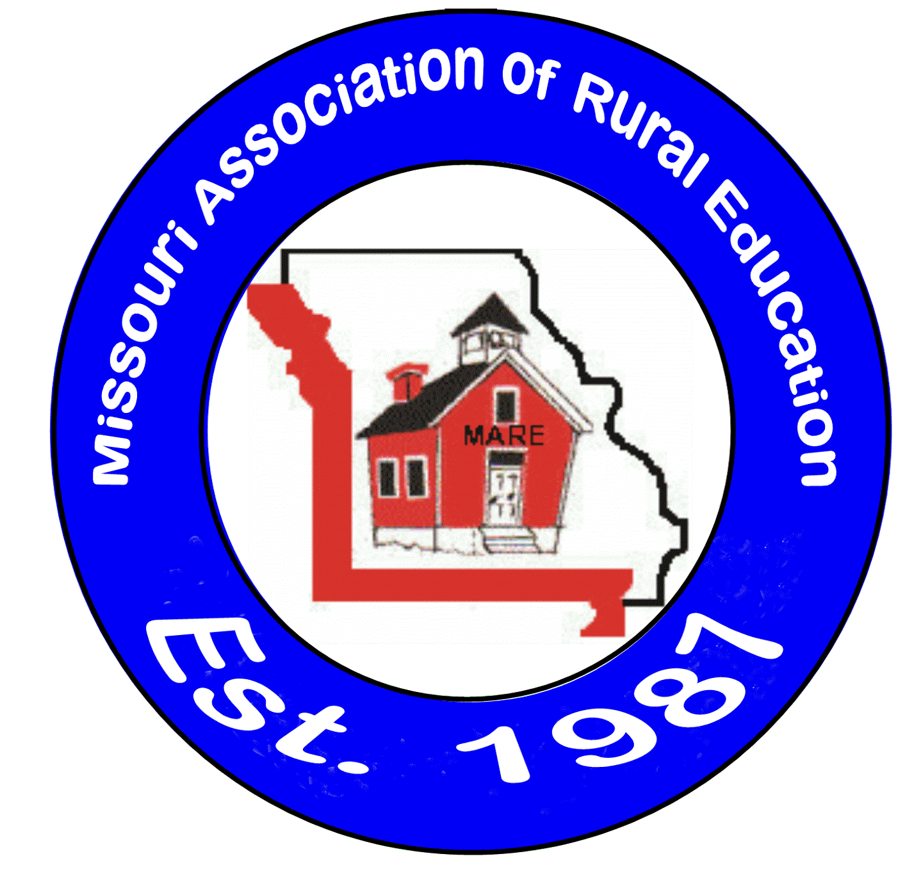Outstanding Rural Teacher - 2020
Jowell Roellig
Warsaw R-IX School District

Jowell Roellig has been a HS Math teacher for the past 26 years at Warsaw R-IX School District. She also serves as the National Honor Society sponsor for the district.

Superintendent Dr. Shawn Poyser shares, "In my 29 years in education, the past 16 as an administrator, I have only nominated one other teacher for a state award. It is difficult to put into words how dynamic of a teacher and person Jowell is, and has been for our district and community. While her MAP and EOC scores have always been outstanding, that's not really what sets Mrs. Roellig apart. It is her ability to connect with all of her students no matter their background or aptitude for math. Her caring, gracious attitude, energy, enthusiasm and even out of the box teaching strategies, endear her to students, parents, and staff."

Danny Morrison, High School Principal at Warsaw, has this to say, "Mrs. Roellig is a phenomenal teacher and it does not go unnoticed. We often say in education that you can teach an individual the techniques to be an effective teacher, but it can be difficult to teach them to care. Not only is Mrs. Roellig a great teacher, she goes above and beyond and cares tremendously for each and every student. She arrives early, stays late and makes herself available to her students and parents for evening and weekend math questions. For Jowell, teaching is an around the clock job!. I have been an educator for 15 years, and Mrs. Roellig is one of the best teachers and leaders I have ever had the privilege of working with."

Carolynn Fisher, Board Member and retired teacher notes, "Jowell came to Warsaw as a student teacher almost thirty years ago. It was evident then that she loved her job, but more than that, she loved her students. She may have been the person that the phrase, "Students don't care how much you know, until they know how much you care' was created for. Teaching is a calling for Jowell...not a career and certainly not just a paycheck. Above and beyond is her personal creed. Not only is she an exemplary teacher, but she is also a mentor to other teachers and a cheerleader for positive attitude among her colleagues. Jowell is a gem that has glimmered in our district for years. As her time in the classroom draws to a close and a well-deserved retirement approaches, it is my wish that she is recognized for all that she has done for our students, our staff, our school and our community."

We are pleased to recognize Mrs. Jowell Roellig as the 2020 MARE “Outstanding Rural Teacher”. Congratulations!

