Missouri Consultants for Education, LLC
803 West Lockwood Avenue
Glendale, Missouri 63122

Phone: (314) 878-5600
Fax: (314) 878-5607
tmickes@mickesotoole.com
www.moconed.com

March 27, 2020

Dear Superintendent,

As you are aware, congress recently passed the Families First Coronavirus Response Act (FFCRA) which grants District employees sick leave and expanded family and medical leave rights beginning April 1, 2020. To educate employees about these rights, the Department of Labor (DOL) recently issued a requirement that all covered employers provide notice of the rights to their employees by April 1, 2020. DOL has prepared a poster of these notices, which is enclosed. Each covered employer must “post” this notice of the FFCRA requirements in a conspicuous place on its premises. An employer may satisfy this “posting” requirement by emailing or direct mailing this notice to employees, or posting this notice on an employee information internal or external website. Frequently Asked Questions regarding these notice requirements from the DOL is also enclosed.

If you have any questions concerning these notice requirements, or the employee rights afforded under the FFCRA, feel free to call MCE staff members. For more information about MCE’s policy service, visit our website at http://www.moconed.com.

Sincerely,

MISSOURI CONSULTANTS FOR EDUCATION, LLC
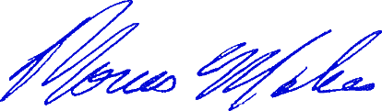

Thomas A. Mickes
TAM/bln

